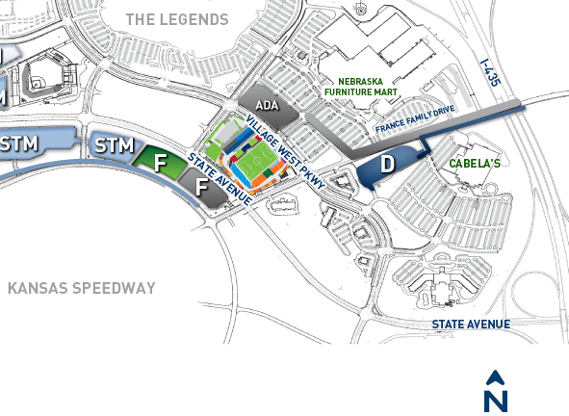

Event Parking at the Speedway – Lot F – Available from 5:30 a.m. – 2:00 p.m.
From I-435: Exit 13B Stave Ave. West. Make Left onto Watkins Glenn Drive (star) to enter into Speedway property and follow as directed into LOT F. Look for directional parking signage to guide you.
From I-70: Take I-435 North. Exit 13B Stave Ave. West. Make Left onto Watkins Glenn Drive (star) to enter into Speedway property and follow as directed into LOT F. Look for directional parking signage to guide you.
Accessible Loading & Unloading Zone: Will be available the morning of the walk along Village West Parkway, 150 ft east of 1 Sporting Way aka Prairie Crossing (arrow).
*Please Note: There is NO PARKING available at the Legends, Nebraska Furniture Mart or
Cabela’s for this event. Event attendees parked at these locations may be towed. However, you are welcome to move your car to one of those places after the event as a patron All cars in Lot F must be moved by 2:00 p.m. so that they can prepare for the game, regardless of if you are attending the game or not.

